**CALCULATOR :**

def add(x, y):

return x + y

def subtract(x, y):

return x - y

def multiply(x, y):

return x * y

def divide(x, y):

return x / y

print("Select operation.")

print("1.Add")

print("2.Subtract")

print("3.Multiply")

print("4.Divide")

while True:

choice = input("Enter choice(1/2/3/4): ")

if choice in ('1', '2', '3', '4'):

num1 = float(input("Enter first number: "))

num2 = float(input("Enter second number: "))

if choice == '1':

print(num1, "+", num2, "=", add(num1, num2))

elif choice == '2':

print(num1, "-", num2, "=", subtract(num1, num2))

elif choice == '3':

print(num1, "*", num2, "=", multiply(num1, num2))

elif choice == '4':

print(num1, "/", num2, "=", divide(num1, num2))

# check if user wants another calculation

# break the while loop if answer is no

next_calculation = input("Let's do next calculation? (yes/no): ")

if next_calculation == "no":

break

else:

print("Invalid Input")

output :

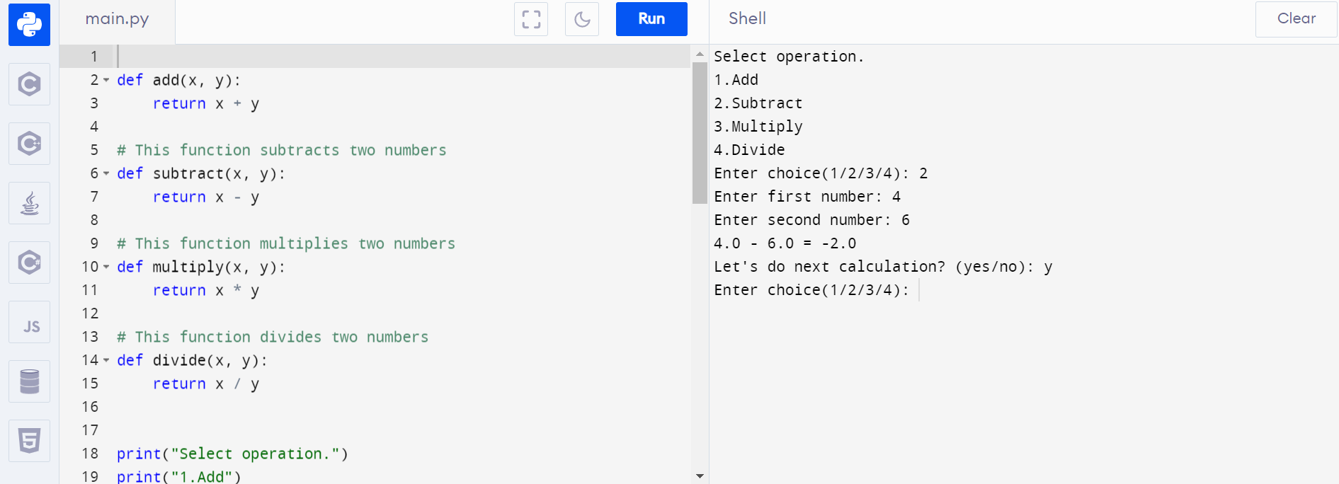

**Concatenation of string :**

var1 = "Hello "

var2 = "World"

# + Operator is used to combine strings

var3 = var1 + var2

print(var3)

output :

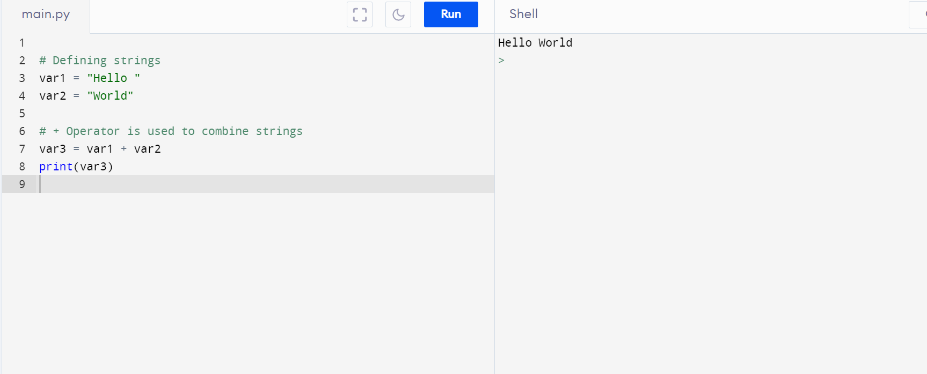

**Reverse of string :**

# Python code to reverse a string

# using reversed()

# Function to reverse a string

def reverse(string):

string = "".join(reversed(string))

return string

s = "Geeksforgeeks"

print("The original string is : ", end="")

print(s)

print("The reversed string(using reversed) is : ", end="")

print(reverse(s))

output :

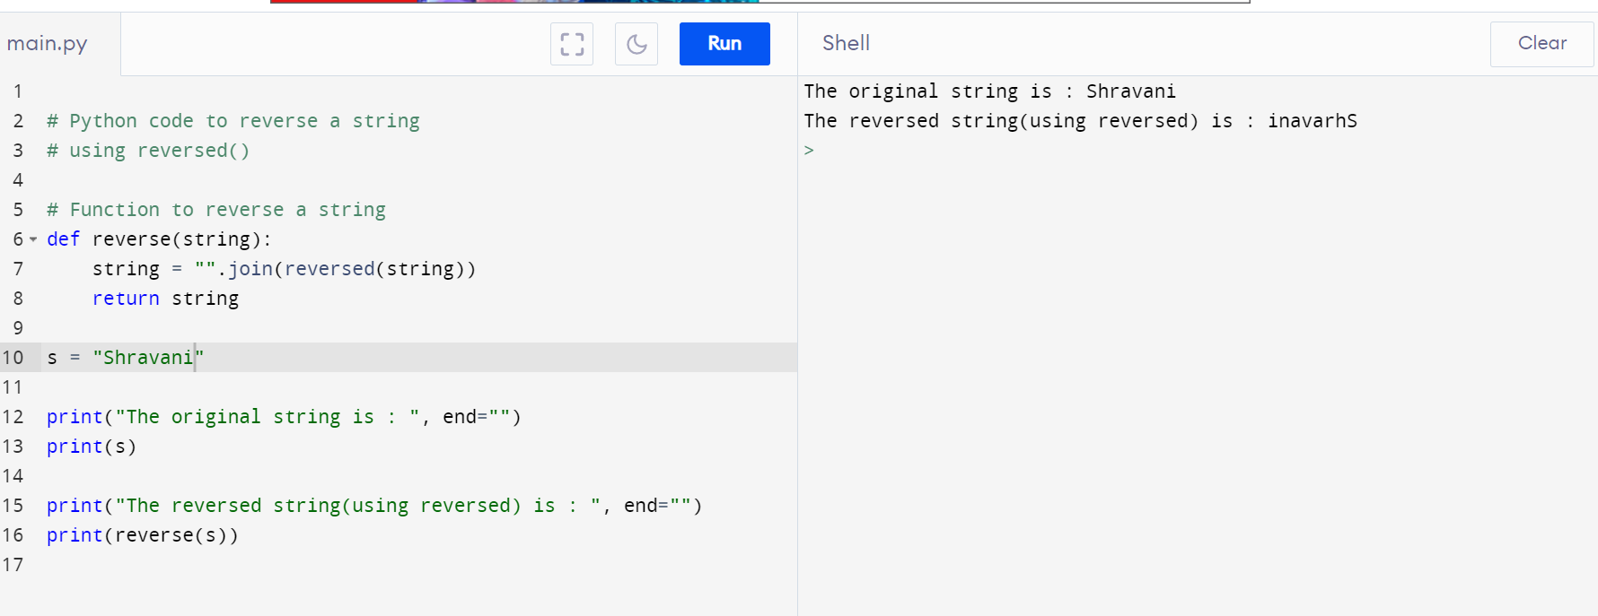

**Slicing a string :**

# Python program to demonstrate

# string slicing

# String slicing

String = 'ASTRING'

# Using slice constructor

s1 = slice(3)

s2 = slice(1, 5, 2)

s3 = slice(-1, -12, -2)

print(& quot

String slicing & quot

)

print(String[s1])

print(String[s2])

print(String[s3])

output :

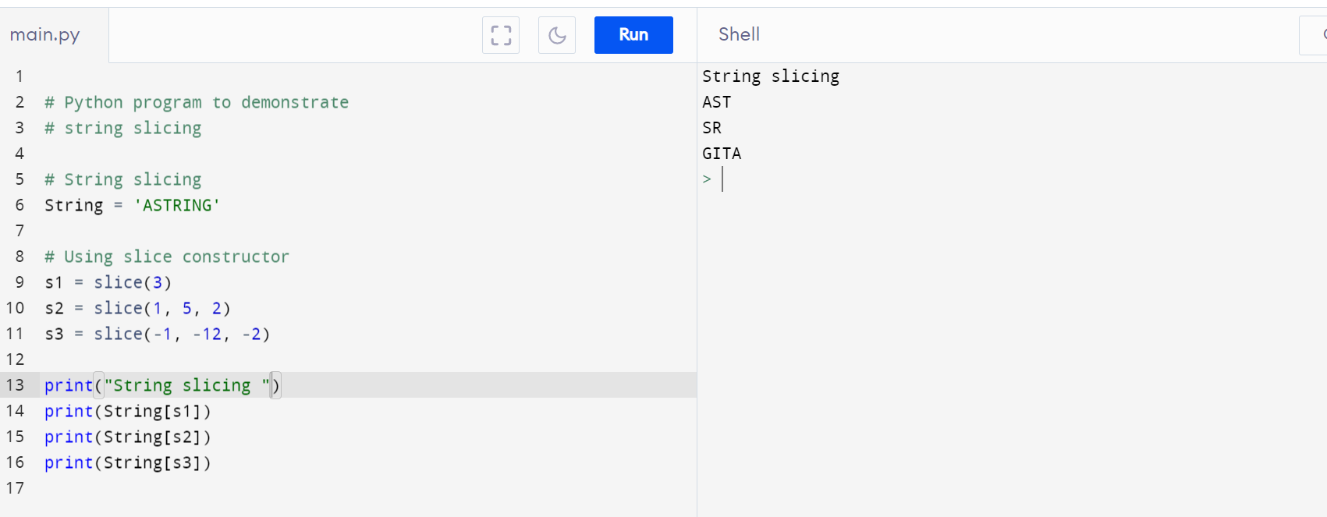

**why is python the most popular programming language**

##### **Python is Easy to Learn and Use**

##### Python is incredibly easy to learn and use for beginners and newcomers in the industry. The language is the most accessible among all the programming languages available because it has simplified syntax that is not complicated at all and gives more emphasis on natural language. Due to its ease of learning and usage, Python codes can easily be written and executed much faster than other [programming languages](https://www.analyticsinsight.net/top-10-python-data-science-courses-you-should-take-up-in-2022/). One of the main reasons why Python’s popularity has exponentially grown is due to its simplicity in syntax so that it could be easy to read and developed by amateur professionals as well.

**Python is Handy for Web Development Purposes**

According to expert professional web developers, Python is among the most convenient programming languages among the other alternatives. Due to the availability of its vast range of applications with in-built solutions to standard web development tasks, the speed of a single project increases by many times.

##### **The Language is Extensively used in Data Science**

Whichever path you choose in the tech world, data will always be a part of it. Currently, Python is extensively used in data science. The amounts of data generated by data analytics tools are increasing every day, hence, experts need to learn programming languages like Python to handle advanced technologies for data analytics. Data professionals also need to stay updated with the latest tech developments in the industry to leverage the most advanced technologies.

##### **Has Multiple Libraries and Frameworks**

Python is quite popular due to its hundreds of different libraries and frameworks that can be used by developers. These libraries and frameworks are really useful in saving time which in turn makes the language even more useful. Some of the most popular libraries available in Python are NumPy and SciPy, Django, and others that are used for different purposes.

##### **Python can be used in ML tool**

Python is used in big data and machine learning research purposes to enhance development in those fields. Python is extremely useful in the AI domain and is also used in robotics and other tech advancements, besides data science.

**Frameworks in python :**

### **1. Django 2. Pyramid 3. TurboGears 4. Web2py 5. CherryPy**

### 

### 

### 

### 